**CAPSTONE PROJECT- THE BATTLE OF NEIGHBOURHOODS**

**21ST AUGUST,2020**

**1 CAPSTONE PROJECT**

**1.01 INTRODUCTION**

Visakhapatnam is the executive capital of the state, “Andhra Pradesh” in India. The city has a population of 17.3 lakhs as per the census 2011.Visakhapatnam is lovingly called as “Vizag” by its citizens.

The coastal city got diversified menu in almost all the restaurants. Sea foods being the specialty of the city, the type of dishes they offer cover the tastes right from North India to South India. So, when we are looking out to choose a right location for our restaurant the following aspects of a location are considered:

1. **How accessible is the location?**

The Business location should be a free to access for the customers without any special restriction confined to the chosen place.

1. **How visible is the location?**

The Business location chosen should be visible to the people so that they can go in whenever there is a desire to eat. (Indirect Brand positioning)

1. **Who are the competitors?**

Are there any competitors? If so how strong are they in that location would we be able to survive such competition in the starting stages.

1. **What are the places of interest around the location chosen (trending venues)?**

If a location has trending venues around it where more people visit those venues daily, there is higher chance they can come to our restaurant.

1. **Is there at least one restaurant in the neighborhood?**

As zero restaurants indicates the place has not given some good business in that niche.

**1.02 BUSINESS PROBLEM**

The major objective of this project is to choose a location for the restaurant in the city, “Visakhapatnam” of “Andhra Pradesh” of “India” with assumptions that, the menu contains both North Indian and south Indian cuisine and the crime rate of the city is uniform and at undisturbedly levels.

**1.03 DATA SECTION**

**This section speaks about which data is used to carry out the analysis?**

The data sets we use in this project should be able to answer all the questions mentioned in the introduction part. So here are the data sets that we use for finding the business location in “Visakhapatnam”

1. **The Foursquare API’s dataset**, this is used to find all the restaurants and hotels in the clusters and details like tips and trending venues can also be found.
2. **Zomato India dataset from Kaggle/Zomato website**, this dataset is used in the perception that the users of restaurants frequently use Zomato more than foursquare to give their ratings. So, in a city like this is more dependable in order to know the nature of our competitors.

Thus, these are the data sets used in this project for choosing the right location.

**1.04 APPROACH**

* First through foursquare API the list of restaurants and hotels are made.
* Map of the district is to be shown after clustering.
* Ratings of the hotels/restaurants are collected from Zomato website/dataset.
* Ratings of every hotel in cluster are shown in bar graphs.
* Nearby venues are also shown in the form of bar graphs.
* Conclusions are given.
  1. **EXTRACTING DATA FROM FOURSQUARE API**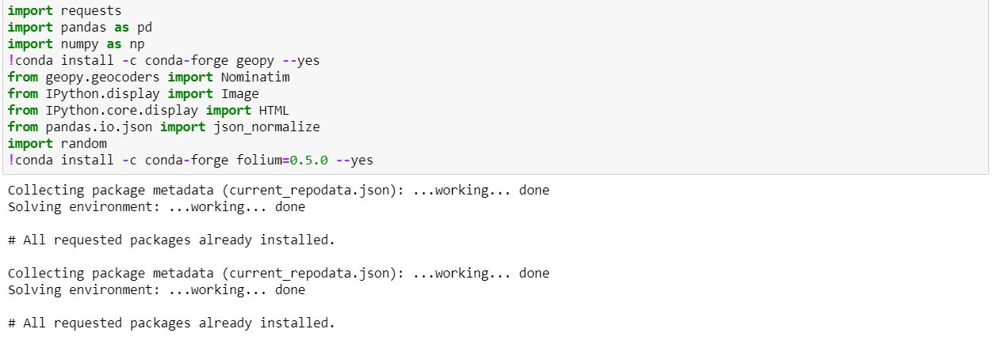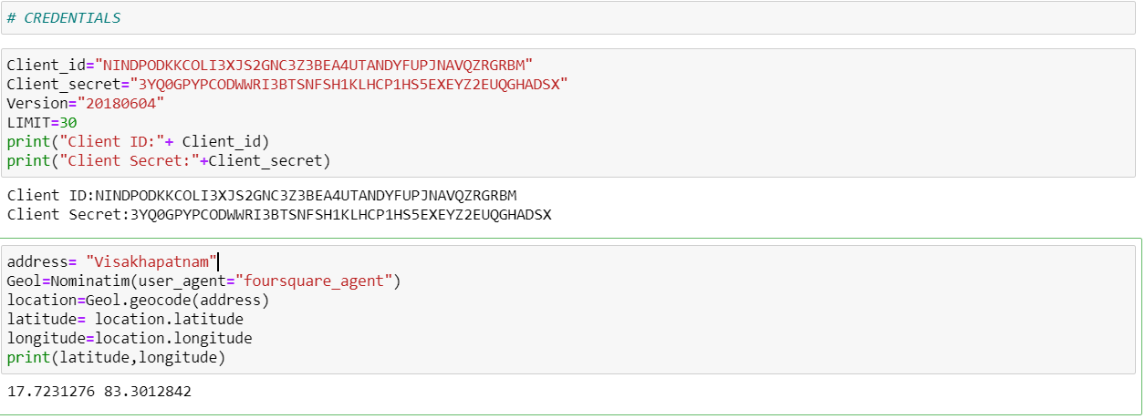

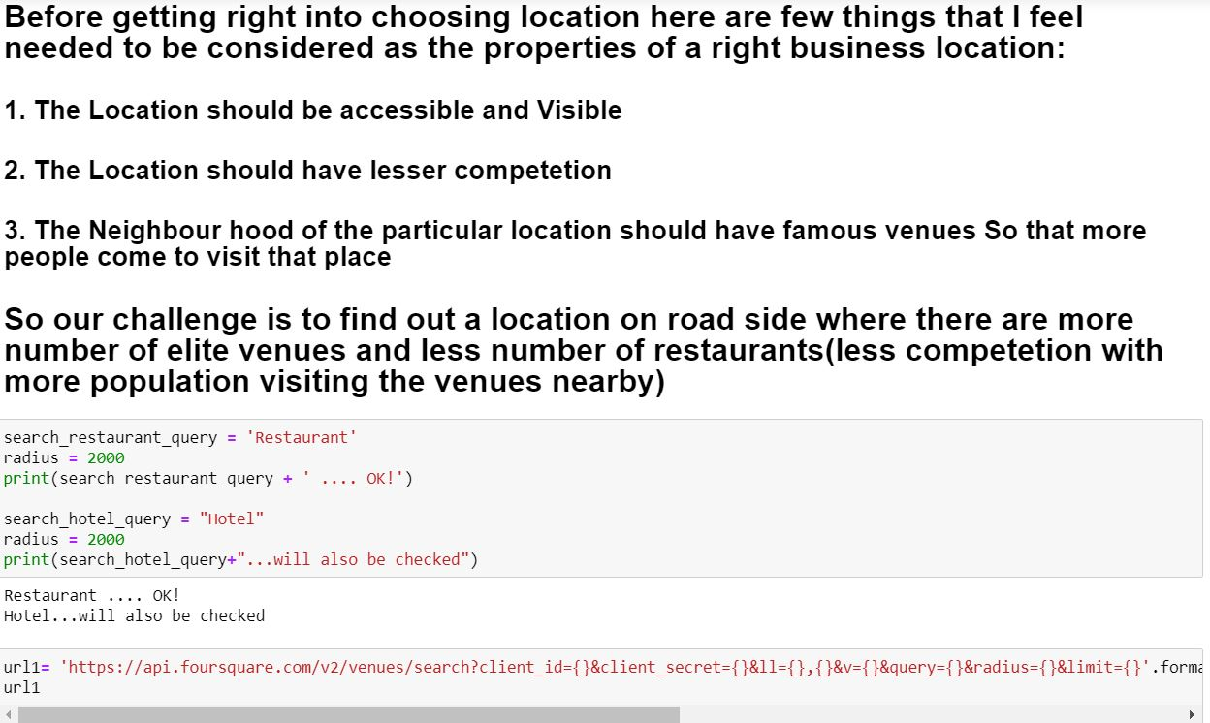

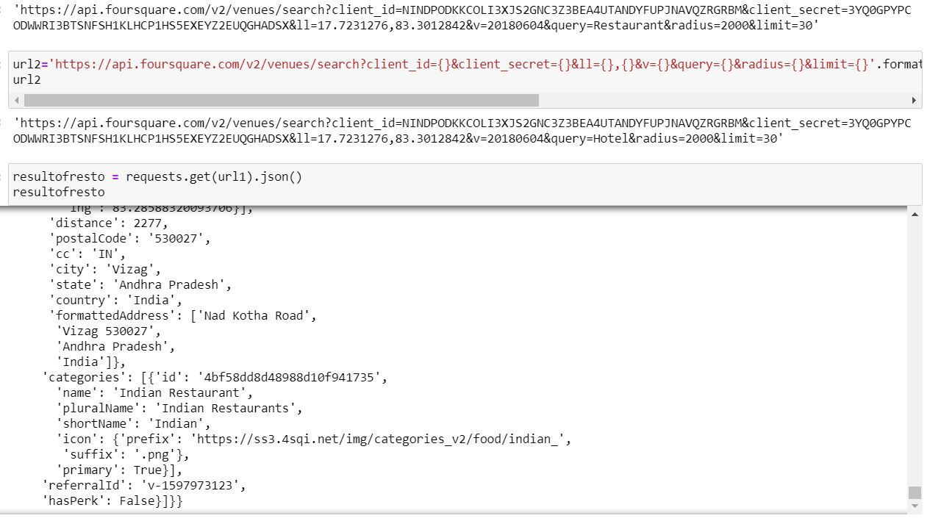

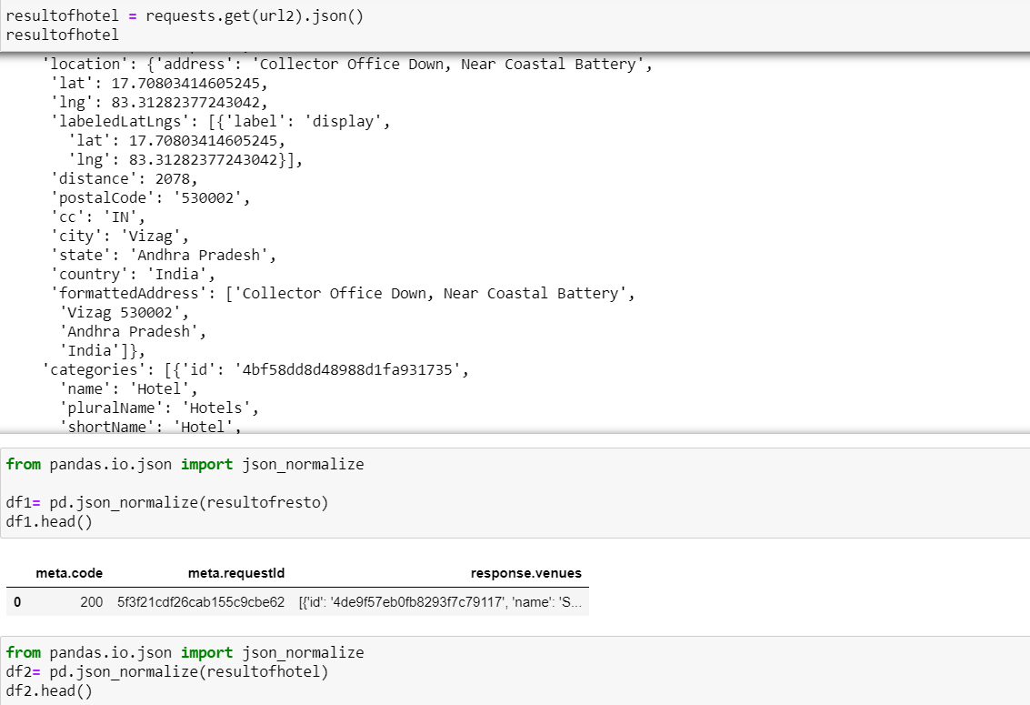

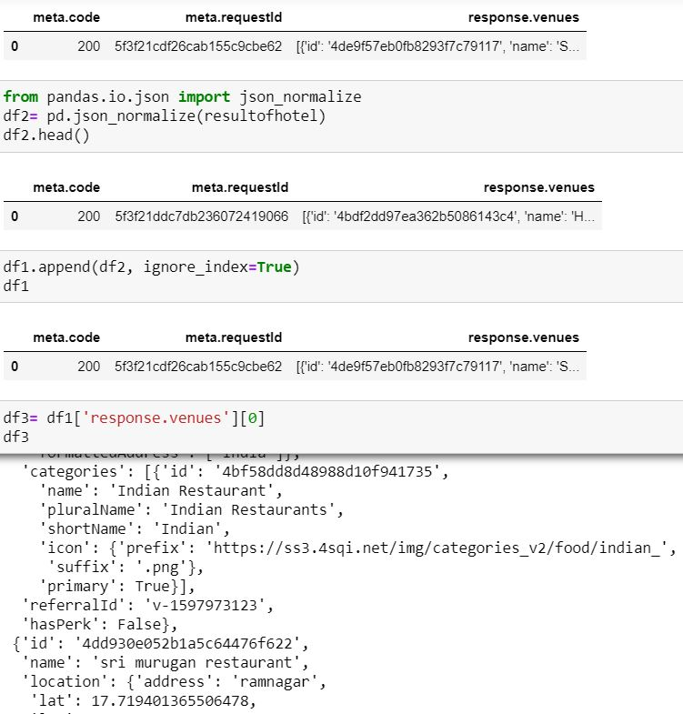

* 1. **DATA CLEANING**

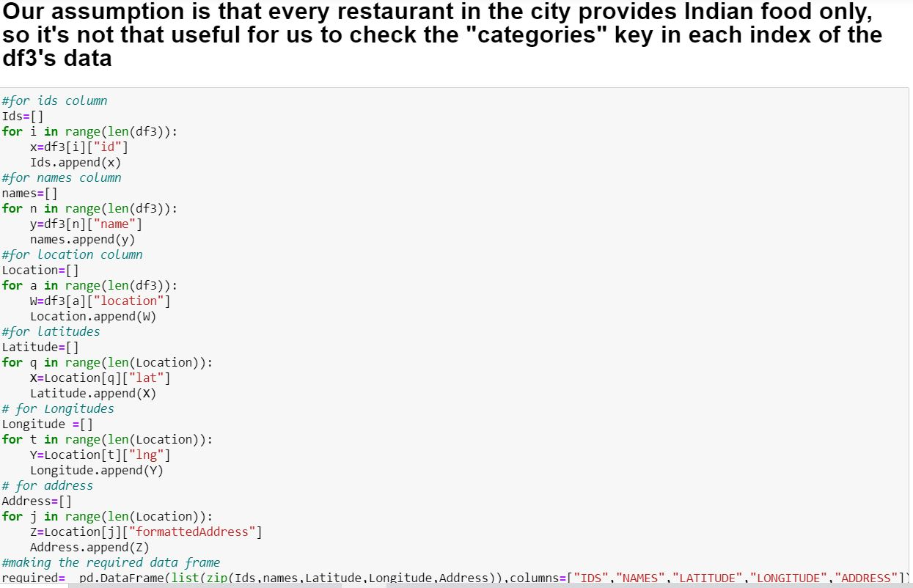

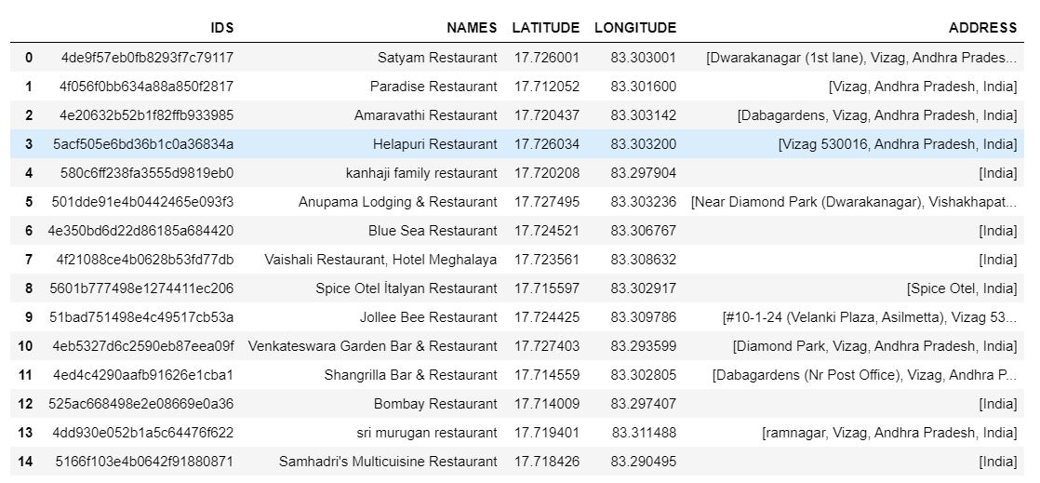

**..**

* + 1. **CREATING CLUSTERS**

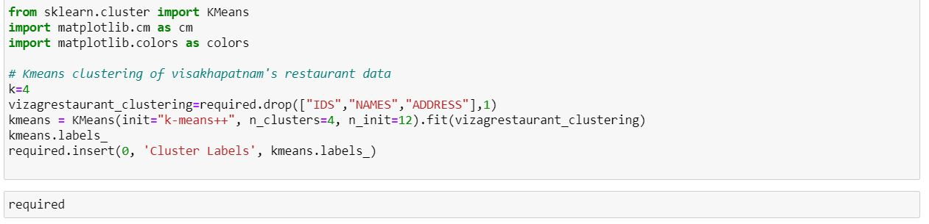

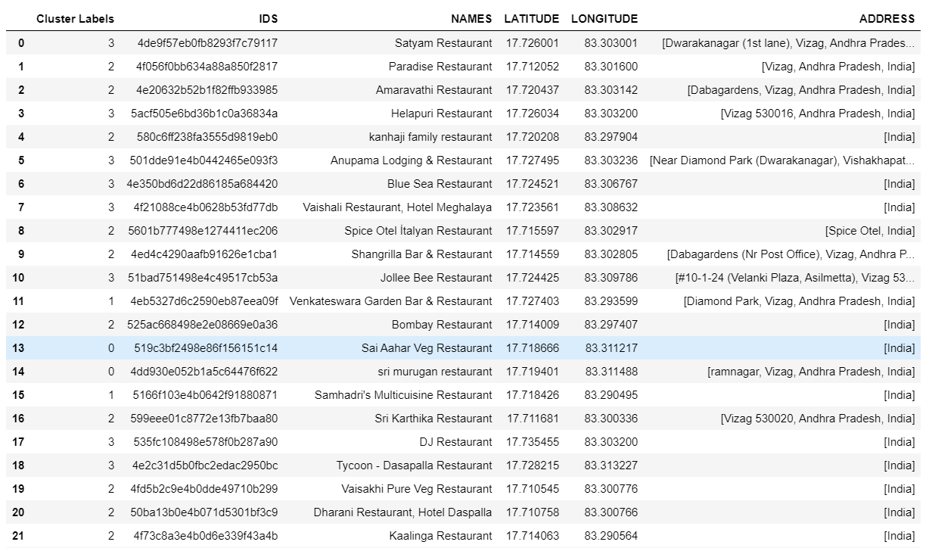

**..**

* + 1. **CREATING MAPS SHOWING CLUSTERS**

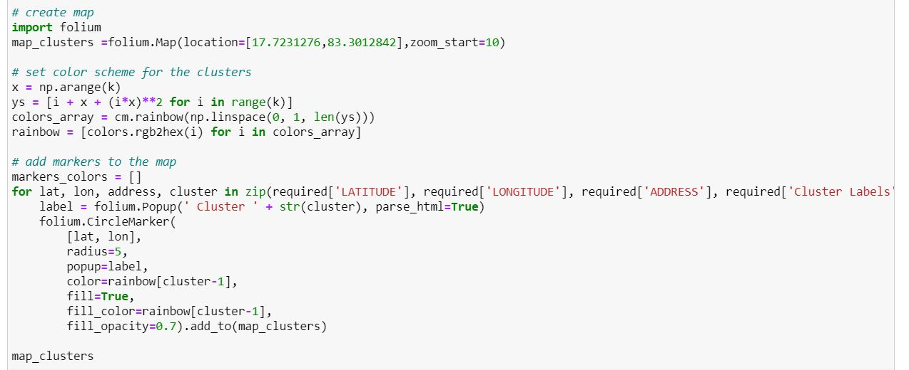

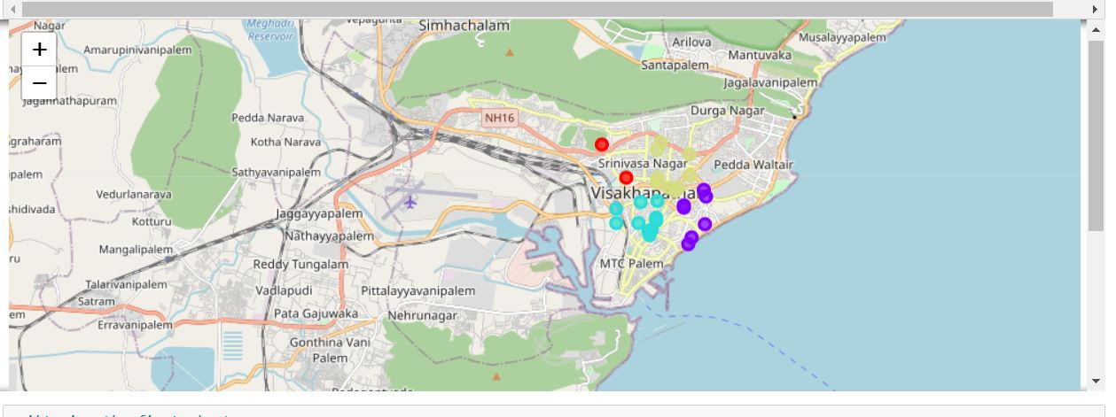

* + 1. **SEPERATING CLUSTERS**

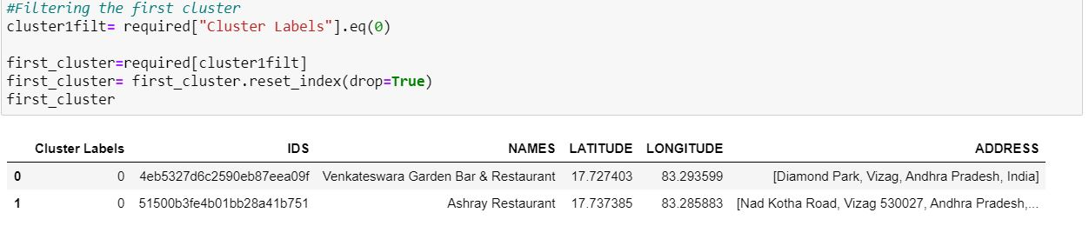

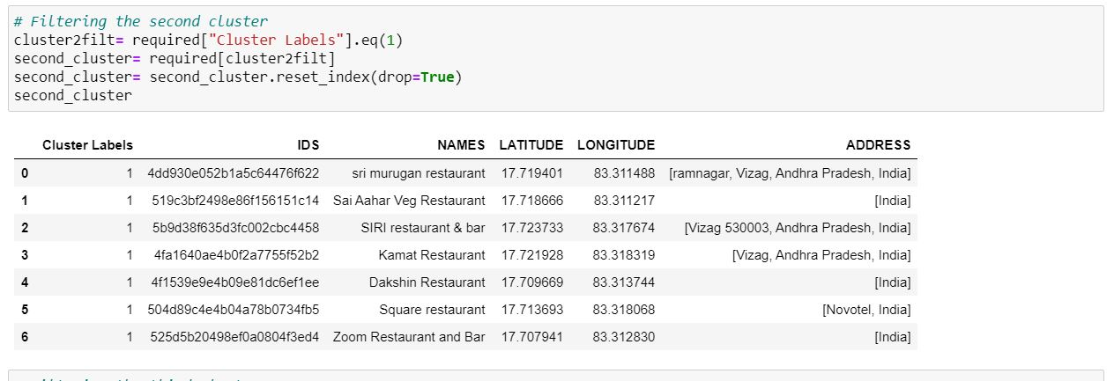

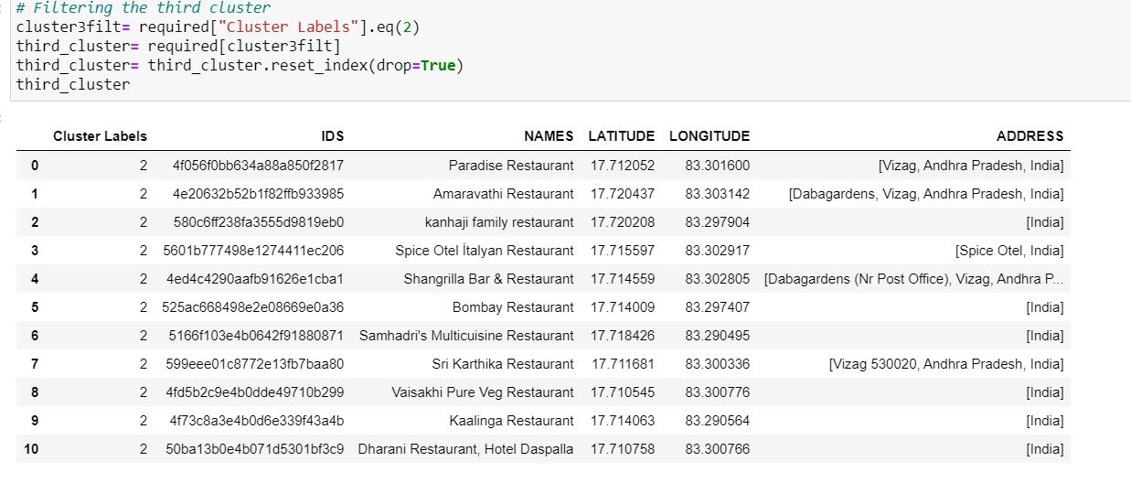

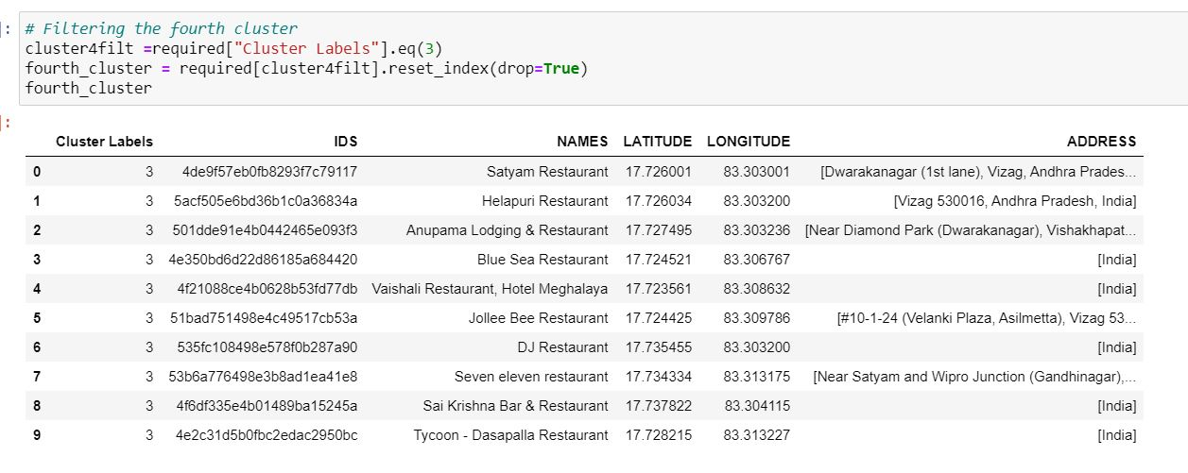

* 1. **VISUALIZTION OF HIGHEST RATINGS(CLUSTER WISE)**

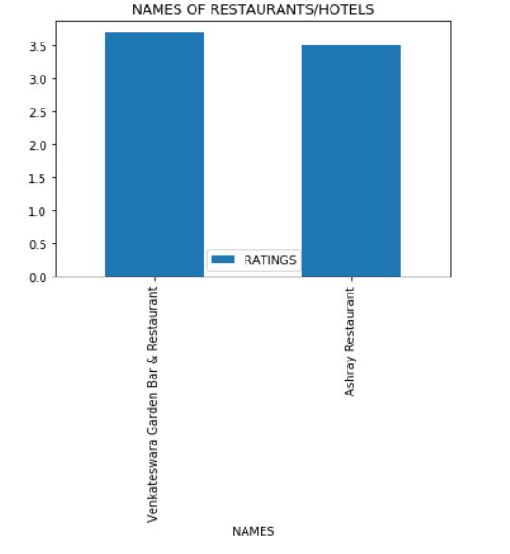**FIRST CLUSTER**

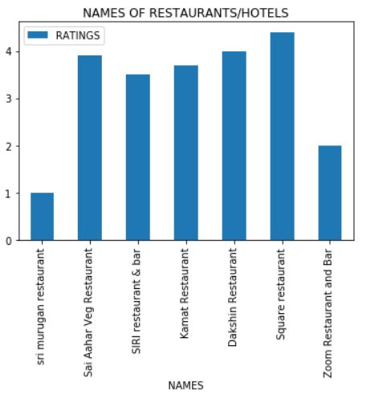**SECOND CLUSTER**

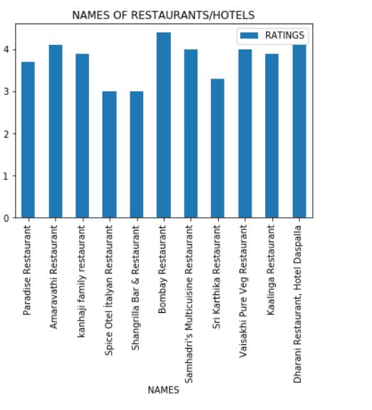**THIRD CLUSTER**

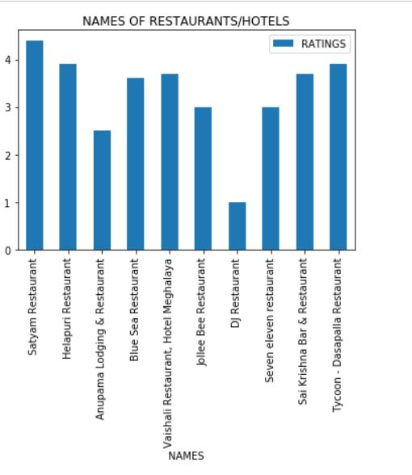**FOURTH CLUSTER**

* 1. **HIGHEST NUMBER OF VENUES IN SURROUNDINGS:**

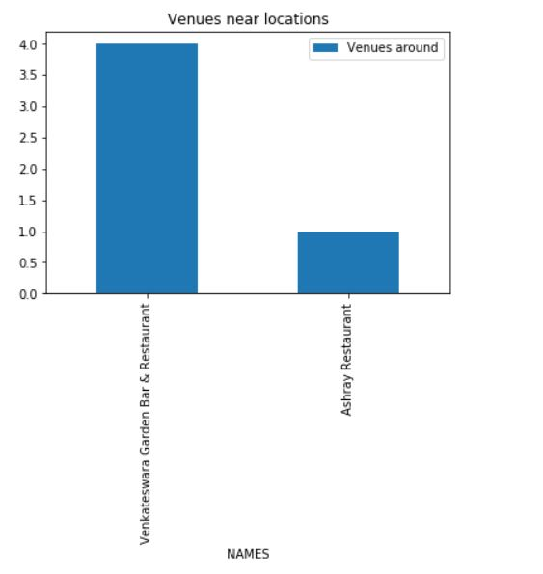**FIRST CLUSTER**

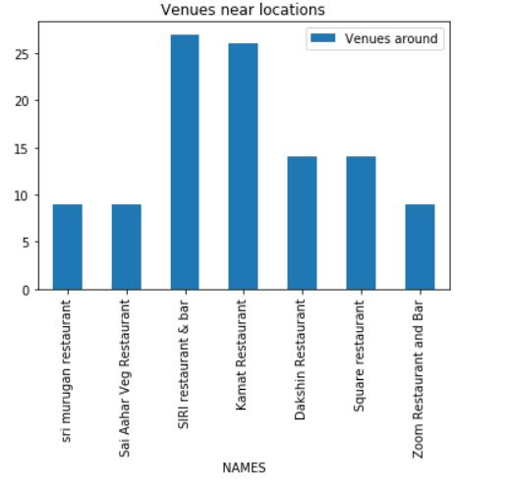**SECOND CLUSTER**

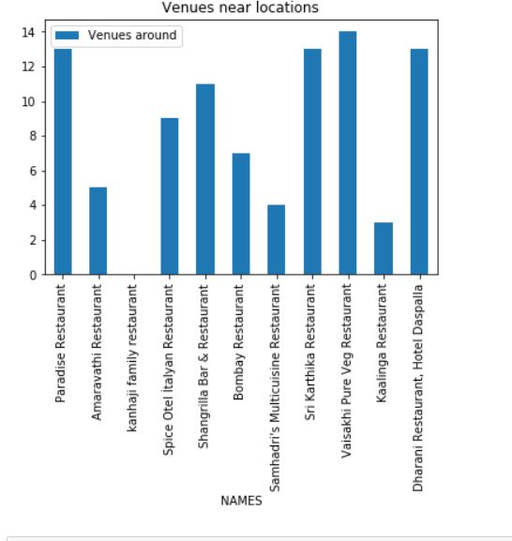**THIRD CLUSTER**

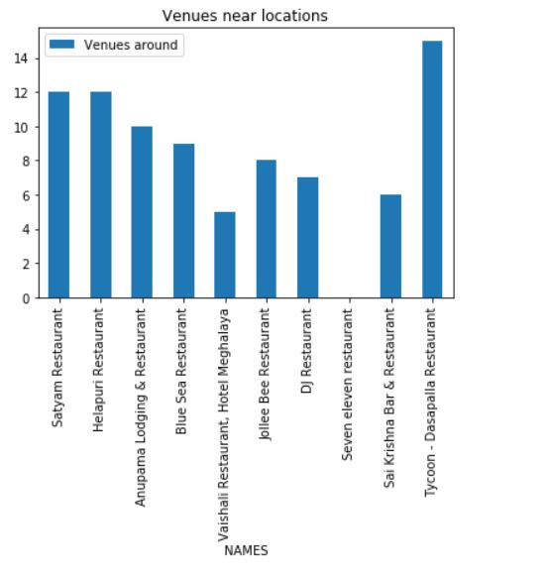**FOURTH CLUSTER**

**CONCLUSION:**

FIRST CLUSTER:

The "Venkateswara garden Bar & Restaurant" has the higher rating than "Ashray"(though it has fair enough rating).The number of venues are more near to "Venkateswara" rather than "Ashray".Hence it will be good if the restaurant is started near to "venkateswara" at a visible and accessible point. The locality in factually near DONDAPARTHY

**SECOND CLUSTER:**

The "Square Restaurant" has the higher rating when compared to all other restaurants in this cluster .Though all other restaurants has the fair ratings. Hotel sri murugan has poor rating ."SIRI restaurant and Bar" has the highest number of venues around. So, it is actually good idea to choose a place around SIRI restaurant or KAMAT because both the rating and venues are of fair number. The actual locality is near "siripuram".

**THIRD CLUSTER:**

The "Bombay Restaurant" has the higher rating when compared to all other restaurants in this cluster .Though all other restaurants has the fair ratings. Hotel spice otel and Shangrilla has lesser rating ."Vaisakhi pure veg" has the highest number of venues around.So, it is actually good idea to choose a place around Vaisakhi restaurant because both the rating and venues are of fair number. The actual locality is near "Jagadamba".

**FOURTH CLUSTER:**

The "Satyam Restaurant" has the higher rating when compared to all other restaurants in this cluster . Though all other restaurants has the fair ratings. Hotel seven eleven has poor rating . "Tycoon restaurant" has the highest number of venues around.So, it is actually good idea to choose a place around Satyam Restaurant restaurant because both the rating and venues are of fair number. The actual locality is near "Dwarakanagar".

THANKYOU COURSERA!!S